Industry 4.0: A Mobile and Compact Modular Factory in Focus with MES and Value Chain

Abstract: To develop a movable and compact modular industry 4.0 factory with a key focus on the manufacturing execution system (MES) and the entire value chain of a product. The main aim of this thesis is to demonstrate an Industry 4.0 model factory. This whole factory can be stored in 3-4 Travel Bags (Small) and can be taken to the lecture halls where live demonstration can be done.

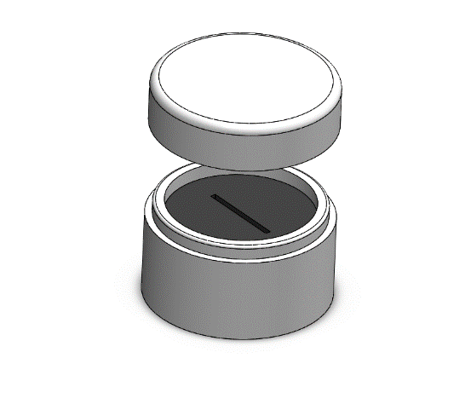Concept: For this concept, the below are to be developed;

Top of Ring Holder

* Customer App

Sponge

* MES in IoT Platform
* Simple product with variations (e.g.: Ring Holder)
* Entire value chain has to be designed
* RFID tag and receiver configuration

Bottom of Ring Holder

* Wireless connections
* Setting up Tablets for Work Stations

The customer can use the pre-installed application on their device to customise the product according to their requirements. Once the customer has placed an order the supplier acquires the raw materials that have to be delivered to the factory. Simultaneously the factory receives details of the ordered products in the IoT platform, which is then sent to the production Line for manufacturing.

The production line receives information and starts production. In this case, the product parts are already manufactured using a 3D printer and stored in a storage area (1) according to the pre-defined product variables. The core of the product (bottom of ring holder) gets an RFID tag and moves to the second section where the Sponge inside the ring holder is fixed and moved to the Assembly area. The same Production Line receives pre-made product 2 (top of the ring holder) to which the RFID tag is attached and passed to the next section where a printed sticker for customer specific Brand is placed on top.

Next, in the assembly area the product is assembled and passed to quality check area, where necessary quality checks are conducted. The product then moves to the packing and shipping section where it receives the delivery address and time of delivery. The products can be delivered according to requirements of the customer and according to priority. A Detailed view of the factory Layout is given below. The wire frames of the Customer App are also shown below.

**About Product:** This product (Ring Holder) gives the impression of a real product. This product has a small value chain, and complete value chain has been shown in the Industry 4.0 model Factory. This product can be manufactured in 3D printing machine at university.

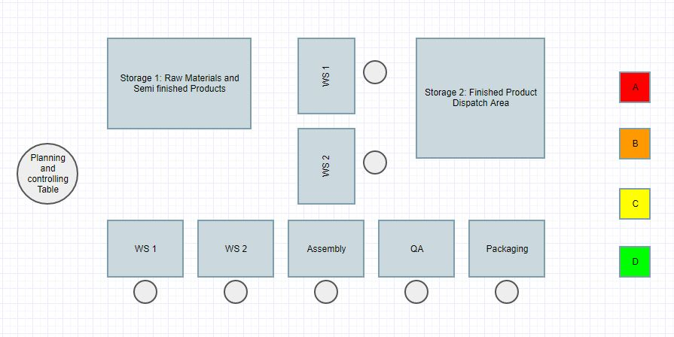

Line 1

Line 2

Customer Ordering Application

(App)

Raw Material Supplier

Customer Delivery Points

Fig.1: The Concept overview of Model Industry 4.0 Factory Layout

The line 1 operates as main Production Line and line 2 can be operated as secondary Production Line or for urgent product requirements.

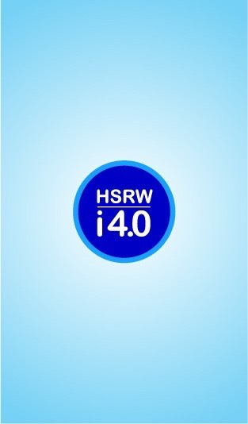 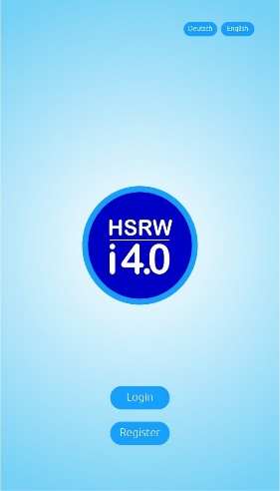 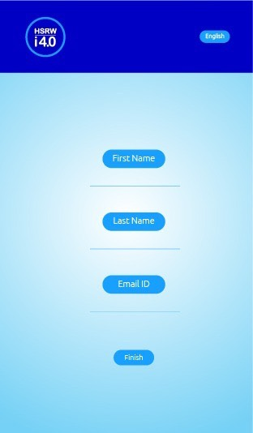 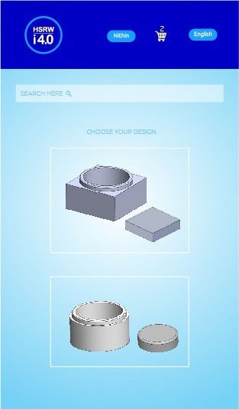

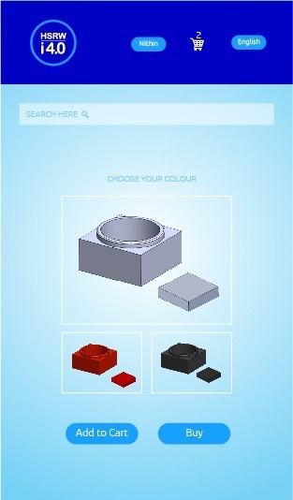 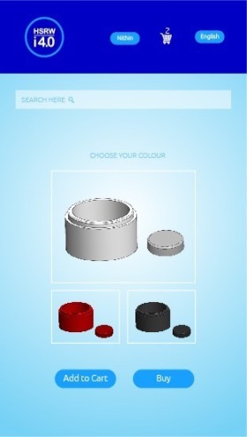 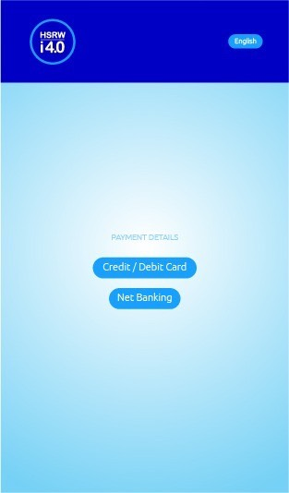 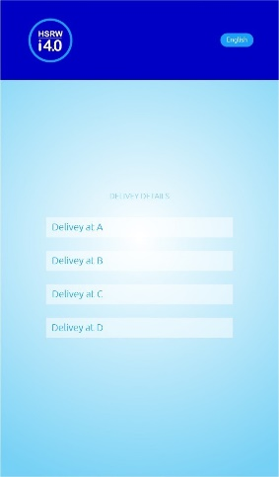

Fig.2: The Wire Frames of Customer Application.